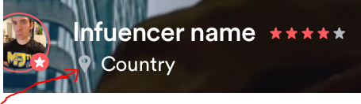

Profile influencer

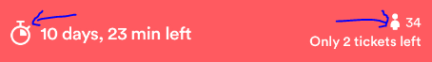
booked event presentation

influencer profile
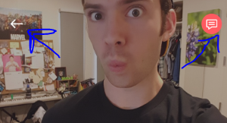
reuqest rejected

